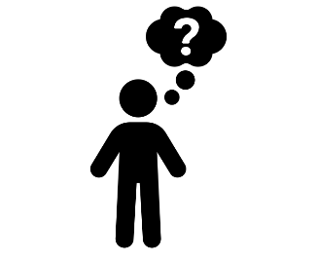 | - Day five activity - Wellbeing  On our final day it’s time to ‘check in’ on the team. A wellbeing focus during MORSE events has been very popular in recent years as we know this is a particular area that many struggle with, especially during the covid pandemic.
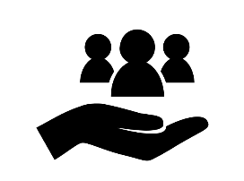 | - Why should we do this?  Wellbeing is fundamental to our health and overall happiness.  Having a strong and well-adapted sense of wellbeing can help us overcome difficulties and help us achieve our goals in life. Research has shown that a greater sense of wellbeing relates to increased physical benefits, such as lower incidences of cardiovascular disease, stroke and sleeping problems. It also increases productivity and creativeness in both our jobs and personal lives.  Looking after our wellbeing helps us to be the best versions of ourselves.
- How?
- Share & care… why not ask the team to ‘check in’ with each other and share how they are feeling – you could ask team members to bring a picture of something important in their life and do a bit of a show and tell.
- Why not reach out to someone you haven’t spoken to or don’t know in the business
- Acts of kindness? Ask the team to do one act of kindness and share with the rest of team…
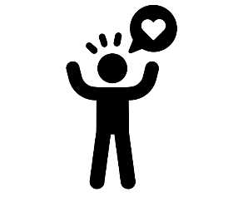 | - How do we want our people to feel?  We want our people to feel valued and that we care.  Actions speak louder than words, so let’s talk to our people and let them know how much we value them.
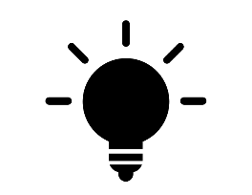 | - Tips & Tricks to help success  There are plenty of tools and help available in the Wellbeing hub to tap into. Why not have a look through the material and information for inspiration and ideas  https://wearemenzies.com/wellbeing

