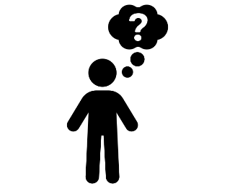 | - Day five activity - Recognition  On our final day of MORSE Week #1 what better time to recognise all the great things our team members do. We know that going the extra mile to make a customer feel special or cared for or ‘doing the right thing’ when faced with an operational safety dilemma can easily go unnoticed.
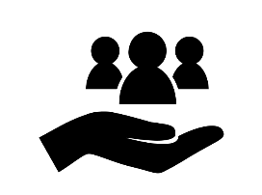 | - Why should we do this?  We work in a busy operation which means that sometimes we forget to acknowledge and recognise our team, colleagues or leaders, yet it is so important that our teams feel valued and appreciated. Let’s make it our mission to make sure we finish the week with some genuine positive recognition and continue recognizing people going forward.
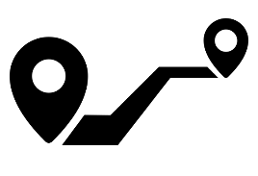 | - How?  Simply by walking around your location and watching your teams as they work will provide opportunities to recognise and acknowledge an action or behaviour.  Reinforce positive behaviours by awarding SMART Excellences. This can be done by you and your management team via our award winning ‘SMART’ app. Start asap, all entries from Jan – April 29th will be entered into the station award. Submit the best ‘Excellence’ into the dedicated teams channel – this will be in the form of a certificate (template will be provided) and don’t forget to take a photo during the presentation please.
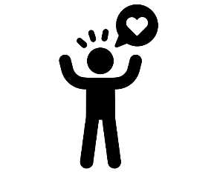 | - How do we want our people to feel?  We want our people to feel valued and that we care.  Actions speak louder than words so let's talk to our people and let them know how much we value them.
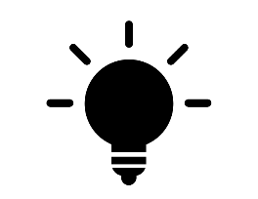 | - Tips & Tricks to help success  Why not use the S.T.A.R method when providing feedback.  S = Situation/Task - Explain the situation or task so others understand the context.  A = Action - Give details about what the person did or the action they took to handle the situation.  R = Result - Describe what was achieved by the action and why it was effective.

