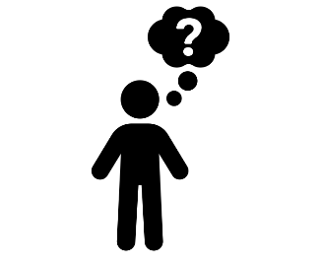 | - Day two activity  Get the brains ticking within your team and play The MORSE Challenge Unlock the code….  Alternatively, why not hold a town hall (or Q&A) meeting and discuss the MORSE code, the Golden rules or the Stop Work Authority…
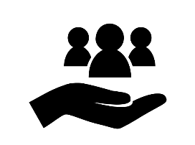 | - Why should we do this?  Playing the quiz, delivers the safety message in a fun and engaging way.  Alternatively, a town hall meeting is a great way to discuss thoughts, feelings and enrich our understanding of safety and security coming first in everything we do.
- How?
For the quiz, you could ask your team members to register an account (if you haven’t already) and login to play all 3 quizzes. There are prizes for the best scores in all quizzes for each region!

For the town hall meeting this could include a reminder of our safety initiatives and culture, why they are our no 1 priority and how every employee can play their part every day.

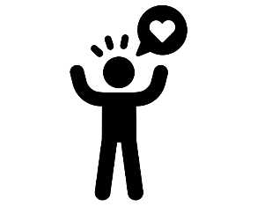 | - How do we want our people to feel?  Every employee has a right to go home every day unharmed to their family and loved ones. Empowering people to make the right choice, every day, the right way!  We want to make sure our people know this and understand how we achieve that through our core principles: the MORSE code, the 10 golden rules, our procedures and stop work authority.  “That’s the way we do safety around here” everyday!
- Tips & Tricks to help success
The quizzes are linked to the recent SLS releases so it might be a good idea to refresh yourself on the content before playing

Why not set up a room in the operation like the quiz show to make the experience as engaging for the team. Take some photos and share them on the MORSE Week Team

