- Day one activity – Menzies Values
Celebrate our values by asking the team what the Menzies values mean to them.

Safety & Security ~ Teamwork ~ Integrity ~ Agility ~ Customer focus

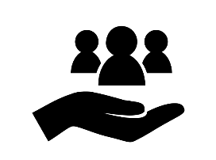 | - Why should we do this?  This is a great way of talking about our values, so our people know and understand them. Living our values will enable us to achieve our ambition and deliver our purpose - setting us apart from our competitors.  Our ambition - we take success seriously and every one of us has an important role in making it happen.  Our purpose - provide safe and trusted aviation services and flexible, sustainable solutions, serving the needs of our customers now and for the future.
- How?
Share the values and their descriptions with team members. You can find these on We Are Menzies.

Ask the team to think of examples of when they demonstrate the values in their role.
- How do we want our people to feel?
We want our teams to feel connected to our values and use them to guide their thoughts and actions every day.

- Tips & Tricks to help success
Why not set up a board and ask the team to share their thoughts and feelings about our values using different coloured ‘sticky notes’ for each value. Which value do you think will get the most comments?

Why not film (on your phone) some of the team sharing what the values mean to them and why, then share on the MORSE Week Teams channel.
