- Day four activity
Do our colleagues really feel empowered to exercise their stop work authority?

A truly safe workplace will only exist if all colleagues accept responsibility for their own health and safety and for that of other people who may be affected by their acts or omissions at work.

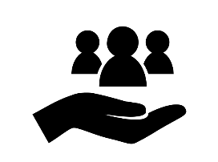 | - Why should we do this?  Everyone has the right and duty to intervene when they feel that their safety or another person’s safety is in danger. When there is a concern relating to health, safety or security you do not have to seek line manager approval before stopping work.  We must work as a team to raise the awareness and the need to follow health, safety & security procedures and our golden rules - Every employee shall be empowered to stop work if they believe that their safety (or that of others) could be compromised.
- How?
Asking the team whether they know the policy exists and what it means to them.

Provide examples that they might encounter in their day-to-day work and discuss how they would approach the situations and what might stop them from speaking up.

- How do we want our people to feel?
We want our people to be confident to stop work when an unsafe situation or task arises and know that they will be supported by their managers and colleagues.

- Tips & Tricks to help success
Why not display a refreshed stop work authority poster in the workplace and get people talking about it. The poster can be downloaded from the MORSE Week 2022 Teams channel.

