- Day three activity
Join our largest Hazard Hunt on day three. Everyone across the network can get involved by looking for hazards in your respective working environment (that goes for terminal or office colleagues) and reporting them.

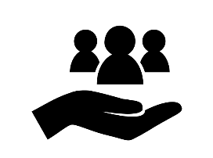 | - Why should we do this?  By spotting and reporting Hazards, we can learn and take proactive measures to prevent incidents from occurring. To help our team members understand the importance of reporting hazards and the link between these important observations and helping to prevent more serious incidents. We have summarised this in our reporting promotional campaign:  Spot the hazard.  Stop the near miss.  Prevent the incident.
- How?
Colleagues can play individually or in groups. Where groups of employees are working together under the leadership of a supervisor or similar, the supervisor should take the lead to encourage, collect and report hazards from employees. Click here to show how this will work.

Record the hazards you see and enter them into the MORSE system.

Don’t forget, hazards can include reporting on third-party activity, actions, inactions or behaviours.

- How do we want our people to feel?
Our colleagues know that we take safety and security seriously and that it’s our number one commitment. Confirming this important message continuously, it will become part of our DNA.

- Tips & Tricks to help success
Have you got the ‘Swift (Frictionless) reporting’ App at your location yet? If not it’s only an email or Teams message away. Once you’re set up, you can report in real time and include images.

Contact: sam.greenwood@menziesaviation.com for the Swift (Frictionless) reporting toolkit

