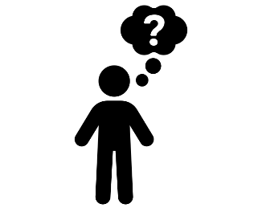 | - Day two activity  Get the brains ticking in the team and host the ‘Who wants to be a MORSillionairE’ quiz.  Alternatively, why not hold a town hall (or Q&A) meeting and discuss the MORSE code, the Golden rules or the Stop Work Authority…
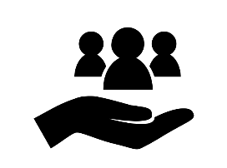 | - Why should we do this?  Playing the quiz, delivers the safety message in a fun and engaging way.  Alternatively, a town hall meeting is a great way to discuss thoughts, feelings and enrich our understanding of safety and security coming first in everything we do.
- How?
For the quiz, you could host it locally with a member of the team in asking the questions or alternatively, why not ask your Menzies 100 (senior manager) visitor to host it? Instructions & Rules are provided on slide 2 of the quiz game when you click on the link above to access the game.

For the town hall meeting this could include a reminder of our safety initiatives and culture, why they are our no 1 priority and how every employee can play their part every day.

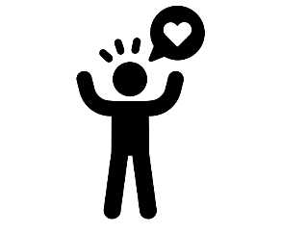 | - How do we want our people to feel?  Every employee has a right to go home every day unharmed to their family and loved ones. Empowering people to make the right choice, every day, the right way!  We want to make sure our people know this and understand how we achieve that through our core principles: the MORSE code, the 10 golden rules, our procedures and stop work authority.  “That’s the way we do safety around here” everyday!
- Tips & Tricks to help success
Why not set up a room in the operation like the quiz show to make the experience as engaging for the team. Take some photos and share them on the MORSE Week 2022 Team

