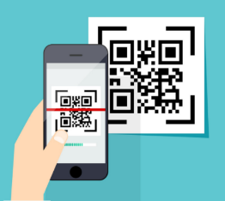

**Scan the QR code and get involved in MM2021**

**Month 2021**

**November 2021**

**Week 1 – Operating**

**Week 2 – Responsibly**

**Week 3 – Safely**

**Week 4 – Effectively**