YOUR HEALTHIEST SELF
Social Wellness Checklist

Positive social habits can help you build support systems and stay healthier
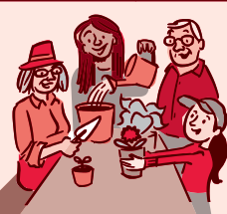
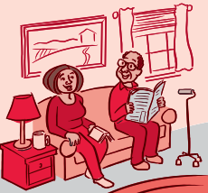
mentally and physically. Here are some tips for connecting with others:

MAKE CONNECTIONS  Social connections might help protect health and lengthen life. Scientists are finding that our links to others can have powerful effects on our health. Whether with family, friends, neighbors, romantic partners, or others, social connections can influence our biology and well-being. Look for ways to get involved with others. | To find new social connections:  - Join a group focused on a favorite hobby.  - Take a class to try something new.  - Try yoga, tai chi, or another new physical activity.  - Join a choral group, theater troupe, band,  or orchestra. Many are now online or virtual.  - Where possible, help at a community garden or park.  - Participate in neighborhood events.  - Join a local community group.
TAKE CARE OF YOURSELF WHILE CARING FOR OTHERS  Many of us will end up becoming a caregiver at some point in our lives. The stress and strain of caregiving can take a toll on your health. It's important  To find ways to care for your health while caring for others. Depending on your circumstances, some self-care strategies may be more difficult to carry out than others. Choose ones that work for you. | To take care of yourself while caring for others:  - Ask for help. Make a list of ways others can help. For instance, someone might sit with the person while you do errands.  - Make to-do lists and set a daily routine.  - Try to take breaks each day.  - Keep up with your hobbies and interests when you can.  - Join a caregiver's support group.  - Eat healthy foods, and exercise as often  as you can.  - Build your caregiver skills. Some hospitals offer classes on how to care for someone with an injury or illness.
For other wellness topics, please visit www.nih.gov/wellnesstoolkits
continued on next page

GET ACTIVE TOGETHER

Where you live, work, or go to school
can have a big impact on how much you move and even how much you weigh. Being active with others in your community can have a positive effect on your health habits and create opportunities to connect. You can help your community create ways to encourage more physical activity.

SHAPE YOUR FAMILY’S HEALTH HABITS
Many things can influence a child, including friends, teachers, and the things they see when they sit in front of the TV or computer. If you're a parent, know
that your everyday behavior plays a big part in shaping your child's behavior, too. With your help, kids can learn to develop healthy eating and physical activity habits that last throughout their lives.

To help make a more active community:
- Where possible, start a walking group with friends.
- Consider joining an exercise group. Many are now online or virtual.
- Participate in local planning efforts to develop walking paths, sidewalks, and bike paths.
- Join other parents to ask for more
physical activity at school.
- Try different activities!

To help kids form healthy habits:
- Be a role model. Choose healthy food and activities when together.
- Make healthy choices easy. Have nutritious food and sports gear readily available.
- Focus on making healthy habits fun.
- Limit screen time.
- Check with caregivers or schools to be
sure they offer healthy food and activities.
- Change a little at a time.

BOND WITH YOUR KIDS

Parents have an important job. Raising kids is both rewarding and challenging. Being sensitive, responsive, consistent, and available to your kids can help you build positive, healthy relationships with them. The strong emotional bonds that result help children learn how to manage their own feelings and behaviors and develop self-confidence. Children with strong connections to their caregivers are more likely to be able to cope with life's challenges.

To build strong relationships with your kids:
- Catch kids showing good behavior and
offer specific praise.
- Give children meaningful jobs at home
and positive recognition afterward.
- Use kind words, tones, and gestures.
- Spend some time every day in warm,
positive, loving interaction with your kids.
- Brainstorm solutions to problems together.
- Set rules for yourself for mobile devices
and other distractions.
- Ask about your child's concerns, worries, goals, and ideas.
- Participate in activities your child enjoys.

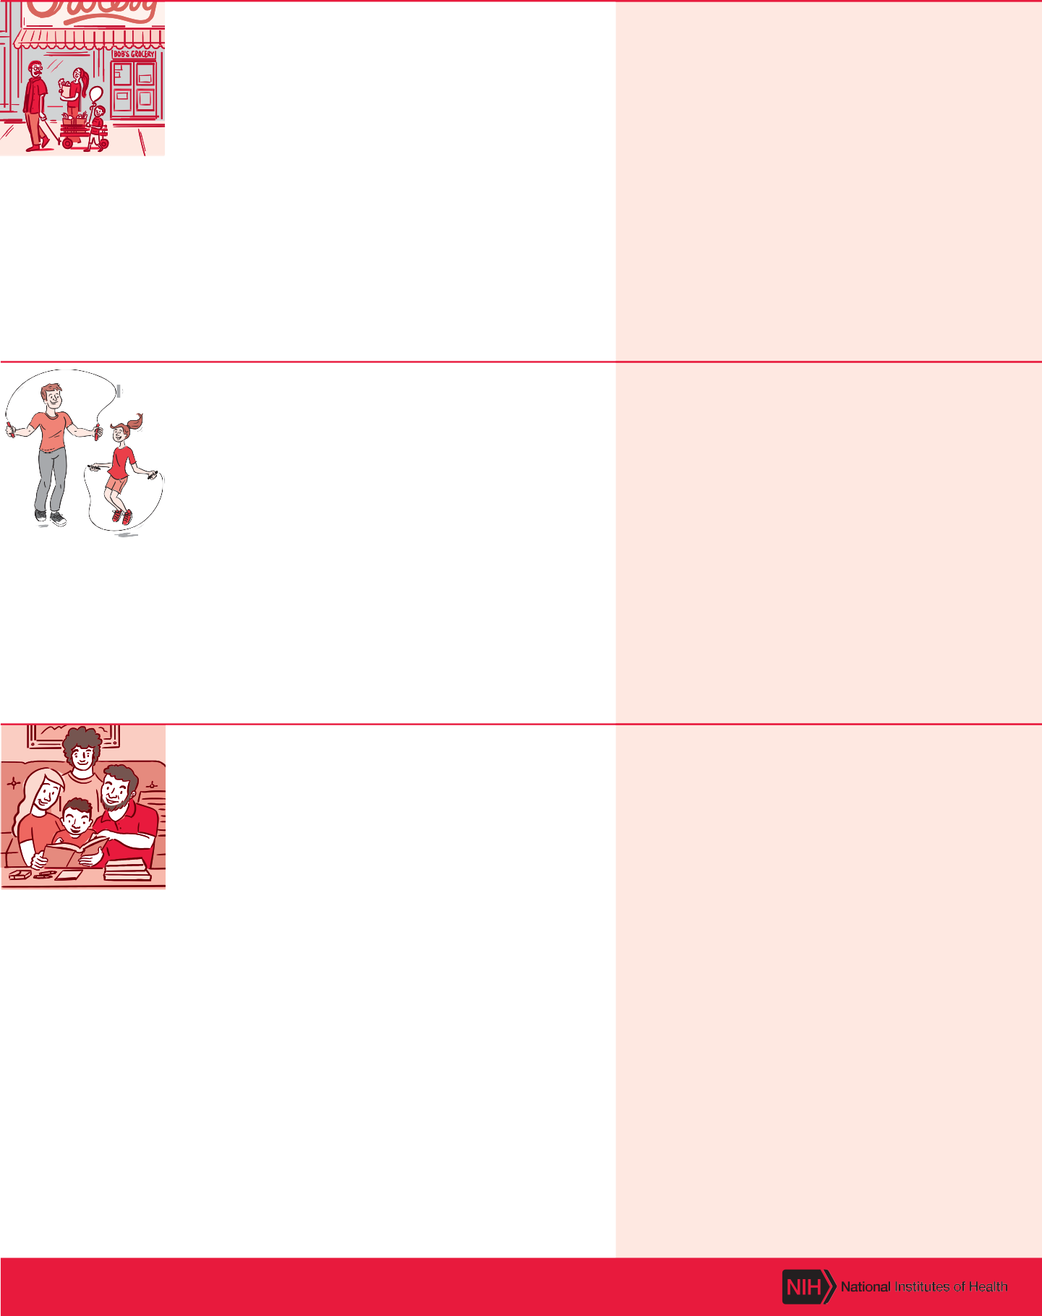

For other wellness topics, please visit www.nih.gov/wellnesstoolkits

BUILD HEALTHY RELATIONSHIPS

Strong, healthy relationships are important throughout your life. They can impact your mental and physical well- being. As a child you learn the social skills you need to form and maintain relationships with others. But at any age you can learn ways to improve your relationships. It's important to know what a healthy relationship looks like and how to keep your connections supportive.

To build healthy relationships:
- Share your feelings honestly.
- Ask for what you need from others.
- Listen to others without judgement or
blame. Be caring and empathetic.
- Disagree with others respectfully. Conflicts should not turn into personal attacks.
- Avoid being overly critical, angry outbursts, and violent behavior.
- Expect others to treat you with respect
and honesty in return.
- Compromise. Try to come to agreements that work for everyone.
- Protect yourself from violent and abusive people. Set boundaries with others. Decide what you are and aren’t willing to do. It's okay to say no.
- Learn the differences between healthy, unhealthy, and abusive ways of relating to others.
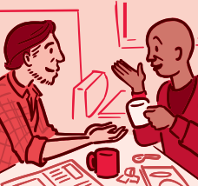

For other wellness topics, please visit www.nih.gov/wellnesstoolkits

