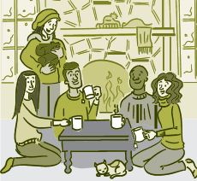
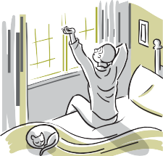
YOUR HEALTHIEST SELF
Emotional Wellness Checklist
Emotional wellness is the ability to successfully handle life’s stresses and adapt
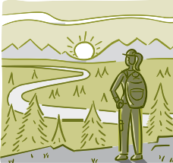
to change and difficult times. Here are tips for improving your emotional health:

BRIGHTEN YOUR OUTLOOK  People who are emotionally well, experts say, have fewer negative emotions and are able to bounce back from difficulties faster. This quality is called resilience. Another sign of emotional wellness is being able to hold onto positive emotions longer and appreciate the good times. | To develop a more positive mindset:  - Remember your good deeds.  - Forgive yourself.  - Spend more time with your friends.  - Explore your beliefs about the meaning  and purpose of life.  - Develop healthy physical habits.
REDUCE STRESS  Everyone feels stressed from time to time. Stress can give you a rush of energy when it's needed most. But if stress  lasts a long time (a condition known as chronic stress), those “high alert” changes become harmful rather than helpful.  Learning healthy ways to cope with  stress can also boost your resilience. | To help manage your stress:  - Get enough sleep.  - Exercise regularly.  - Build a social support network.  - Set priorities.  - Think positive.  - Try relaxation methods.  - Seek help.
GET QUALITY SLEEP  To fit in everything we want to do in our day, we often sacrifice sleep. But sleep affects both mental and physical health. It's vital to your well-being. When you're tired, you can't function at your best. Sleep helps you think more clearly, have quicker reflexes and focus better. Take steps  to make sure you regularly get a good  night's sleep. | To get better quality sleep:  - Go to bed and get up each day at  the same time.  - Sleep in a dark, quiet place.  - Exercise daily.  - Limit the use of electronics.  - Relax before bedtime.  - Avoid alcohol, nicotine, & stimulants late in the day.  - Consult a health care professional if  you have ongoing sleep problems.
For other wellness topics, please visit www.nih.gov/wellnesstoolkits
continued on next page

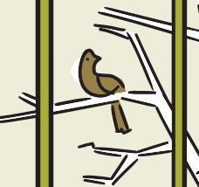
YOUR HEALTHIEST SELF | EMOTIONAL WELLNESS CHECKLIST

continued

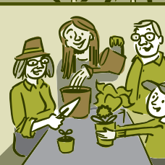
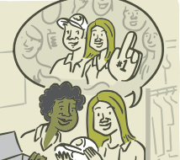

BE MINDFUL  The concept of mindfulness is simple. This ancient practice is about being completely aware of what’s happening in the present, of all that’s going on inside and all that's happening around you. It means not living your life on "autopilot." Becoming a more mindful person requires commitment and practice. Here are some tips to help you get started. | To be more mindful:  - Take some deep breaths in through your nose to a count of 4, hold for 1 second and then exhale through the mouth to a count of 5. Repeat often.  - Enjoy a stroll and notice the sights  around you.  - Practice mindful eating. Be aware of each bite and when you're full.  - Find mindfulness resources in your local community, including classes, programs, or books.
COPE WITH LOSS  When someone you love dies, your world changes. There is no right or wrong way to mourn. Although the death of a loved one can feel overwhelming, most people can make it through the grieving process with the support of family and friends.  Learn healthy ways to help you through  difficult times. | To help cope with loss:  - Take care of yourself.  - Talk to a caring friend.  - Try not to make any major changes right away.  - Join a grief support group.  - Consider professional support.  - Talk to your doctor if you're having trouble with everyday activities.  - Be patient. Mourning takes time.
STRENGTHEN SOCIAL CONNECTIONS  Social connections might help protect health and lengthen life. Scientists are finding that our links to others can have powerful effects on our health, both emotionally and physically. Whether with romantic partners, family, friends, neighbors, or others, social connections  can influence our biology and well-being. | To build healthy support systems:  - Build strong relationships with your friends, colleagues and family.  - Get active and share good habits with  family and friends.  - If you’re a family caregiver, ask for help  from others.  - Join a group focused on a favorite hobby,  such as reading, hiking, or painting.  - Take a class to learn something new.  - Where possible, volunteer for things you care about in your community, like a community garden, school, library, or place of worship.
For other wellness topics, please visit www.nih.gov/wellnesstoolkits

