YOUR HEALTHIEST SELF
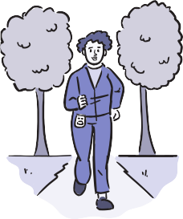
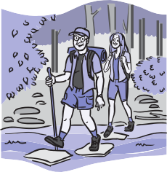
Physical Wellness Checklist
Positive physical health habits can help decrease your stress, lower your risk of disease, and increase your energy. Here are tips for improving your physical health:

GET ACTIVE  How well your body functions affects your ability to accomplish your daily activities. Sedentary behavior—which usually means sitting or lying down while awake—has been linked to a shorter lifespan and a wide range of medical problems. Any time you get up and move, you’re improving your chances  for good health. | To increase your activity:  - Take the stairs instead of the elevator.  - Have “walking meetings” with colleagues, even if they are phone calls.  - Walk on a treadmill while watching TV or using the computer.  - Set an alarm on your computer to go off every hour and prompt you to move around for a minute or two.  - Try walking as if you’re already late.  - Have small weights in your office or home.
MAINTAIN YOUR BODY  Your bones, muscles, and joints all work together to make your body an amazingly movable machine. Like any machine, your body can suffer some  wear and tear. It needs regular care and maintenance to keep moving with ease. | To keep your body healthier:  - Maintain a healthy weight.  - Engage in muscle strengthening activities.  - Aim for 150 minutes of moderate intensity activity each week.  - Wear comfortable, properly fitting shoes.  - Eat a well-balanced diet.  - Always follow your manual handling guidance when lifting heavy objects.
EAT A HEALTHY DIET  We make dozens of decisions every day. When it comes to deciding what to eat and feed our families, it can be a lot easier than you might think to make smart choices. Keeping your body at a healthy weight may help you lower your risk of heart disease, type 2 diabetes, and certain types of cancer that can result from being overweight or obese. Take charge of your weight and your health. | To reach your weight loss goals:  - Eat smaller portions.  - Eat colorful vegetables each day.  - Choose whole grains.  - Go easy on sugar, fats, and oils.  - Stick with activities you enjoy.  - Go for a brisk walk, ride a bike, or do some gardening.  - Do strengthening activities.  - Get active for just 10 minutes, several times a day. Every little bit counts!  - Keep a food and physical activity diary.
For other wellness topics, please visit www.nih.gov/wellnesstoolkits
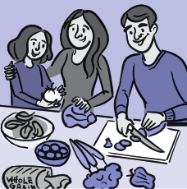
continued on next page

YOUR HEALTHIEST SELF | PHYSICAL WELLNESS CHECKLIST

continued

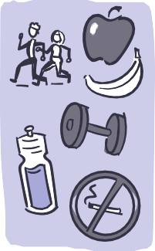  MIND YOUR METABOLISM  Your metabolism changes as you get older. You burn fewer calories and break down foods differently. You also lose lean muscle. Unless you exercise more and adjust your diet, the pounds can add up. Middle-age spread can quickly become middle-age sprawl. Carrying those extra pounds may be harming your health. | To combat age-related changes:  - Commit to a healthy diet.  - Limit snacking.  - Drink plenty of water.  - Move more. Take the stairs and add walking breaks to your day.  - Get plenty of sleep.  - Limit alcohol use.  - Avoid tobacco products. When you quit smoking, you may improve many aspects of your health and are likely to add years to your life.
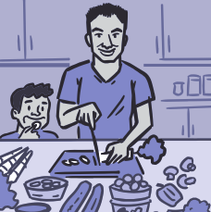  BUILD HEALTHY HABITS  We know that making healthy choices can help us feel better and live longer. Maybe you’ve already tried to eat better, get more exercise or sleep, quit smoking, or reduce stress. It’s not easy. But research shows how you can boost your ability to create and sustain a healthy lifestyle. | To build healthy habits:  - Plan. Set realistic goals.  - Change your surroundings. Remove temptations.  - Ask for support.  - Fill your time with healthy activities.  - Track your progress.  - Imagine the future.  - Reward yourself.  - Be patient. Improvement takes time,  and setbacks happen. Focus on progress, not perfection.

