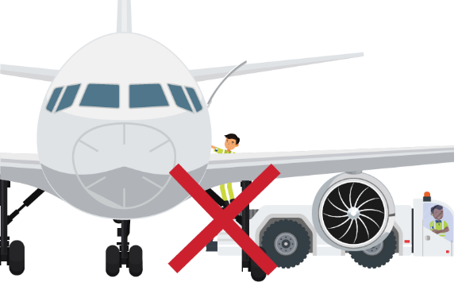

Golden Rules Pop Quiz (Answer Sheet)

No | Name of Track | Points | Artist | Points | Clue Word | Golden Rule | Points
 |  |  |  |  | LEAVE
 |  |  |  |  | YOU
 |  |  |  |  | RIDE
 |  |  |  |  | SPEED
 |  |  |  |  | RULE
 |  |  |  |  | ALL
 |  |  |  |  | BE
 |  |  |  |  | ALWAYS
 |  |  |  |  | BE NEVER
 |  |  |  |  | ONLY
Totals

